Muthu Palaniappan M EX 1

* Display information about files in the current directory

* Display the current working directory.

* Create a new directory

* Navigate between different foldersA computer screen with white text and blue text

  Description automatically generated
* Remove empty directories from the directory lists.

* Copy files from one directory to the same directory

* Copy files from one directory to another directory

* Rename a filename to another name

* Move a file from one directory to another

* Delete individual files from a directory

* Delete an entire directory which contains a few files

* Get basic information about the OS



* Find a file in the directory

* Create empty files

* Display file contents on terminal

* Clear terminal

* Display the processes in terminal

* Access manual for all Linux commands

* Display active processes on the terminal

* Download files from the internet

* Check the details of the file system

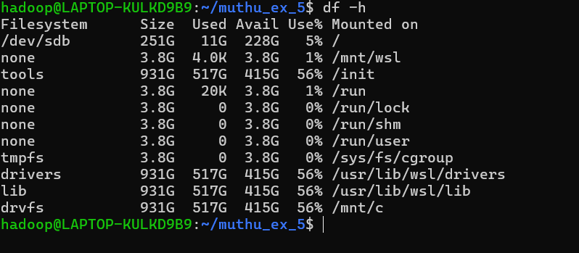

* Check the lines, word count, and characters in a file using different options

